Course Name: | Structured Programming Methodology | Semester: | I
Date of Performance: | 25/10/2025 | DIV/ Batch No: | D-3
Student Name: | Ralston Kenneth Dsouza | Roll No: | D-73

Experiment No: 1
Title: Working with data types and operators

Aim and Objective of the Experiment:
Write a program in C++ to demonstrate the use of data types and operators

COs to be achieved:
CO1: Understand the concepts of data types and operators

Theory:
Area and Circumference of Circle. Ask the user to enter the value of the radius of a circle. Put the values in the formula for finding the area of a circle and the circumference of a circle and print the outcome for area of a circle and the circumference of a circle.

Input of the distance between two cities in kilometers and converting them into meters, centimeters, feet, and inches.
Ex- If there are two cities "Gwalior" and "Delhi", their distance is 500 kilometers, after converting the distance from a kilometer, the distance value will be 500000 meters, 1640420 feet, 19685050 inches, and 50000000 centimeters.

Problem Statements:
Write a program for the following
- Compute the area and circumference of a circle.
- Read the distance between two cities in km and print that distance in meters, feet, inches, and centimeters.

Code :
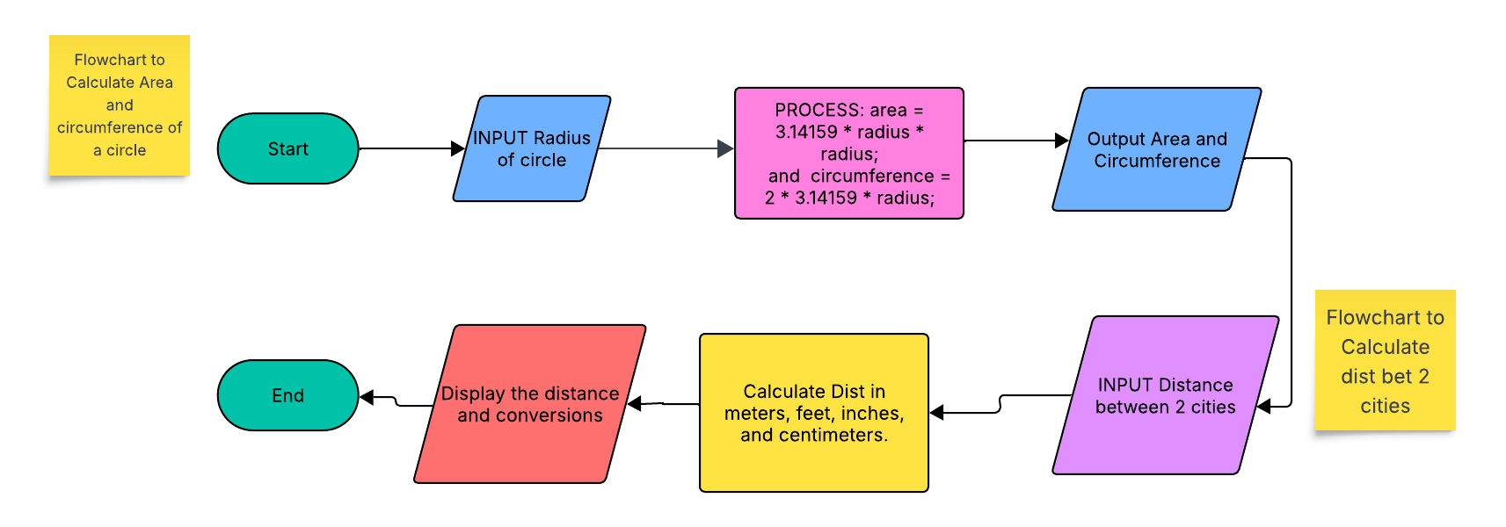
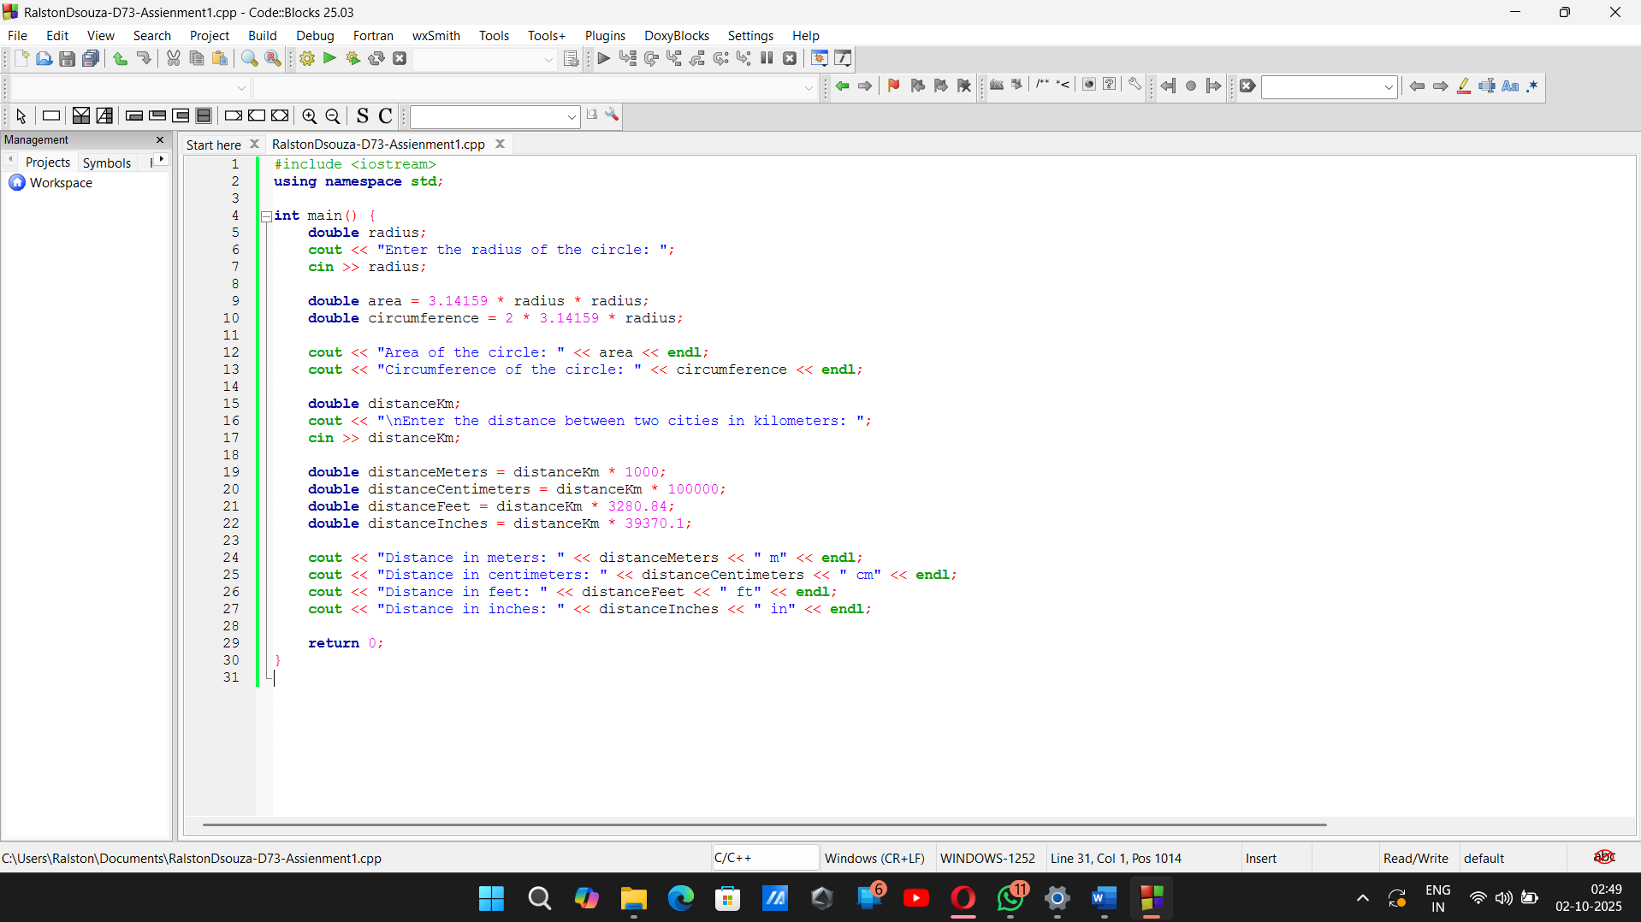
Detailed Algorithm:
Start

Input the radius of the circle
Compute area = π × radius × radius
Compute circumference = 2 × π × radius
Print area and circumference

Input the distance between two cities (in kilometres)
Convert the distance into:
meters = km × 1000
centimetres = km × 100000
feet = km × 3280.84
inches = km × 39370.1
Print the distance in meters, centimetres, feet, and inches

Stop

Output:
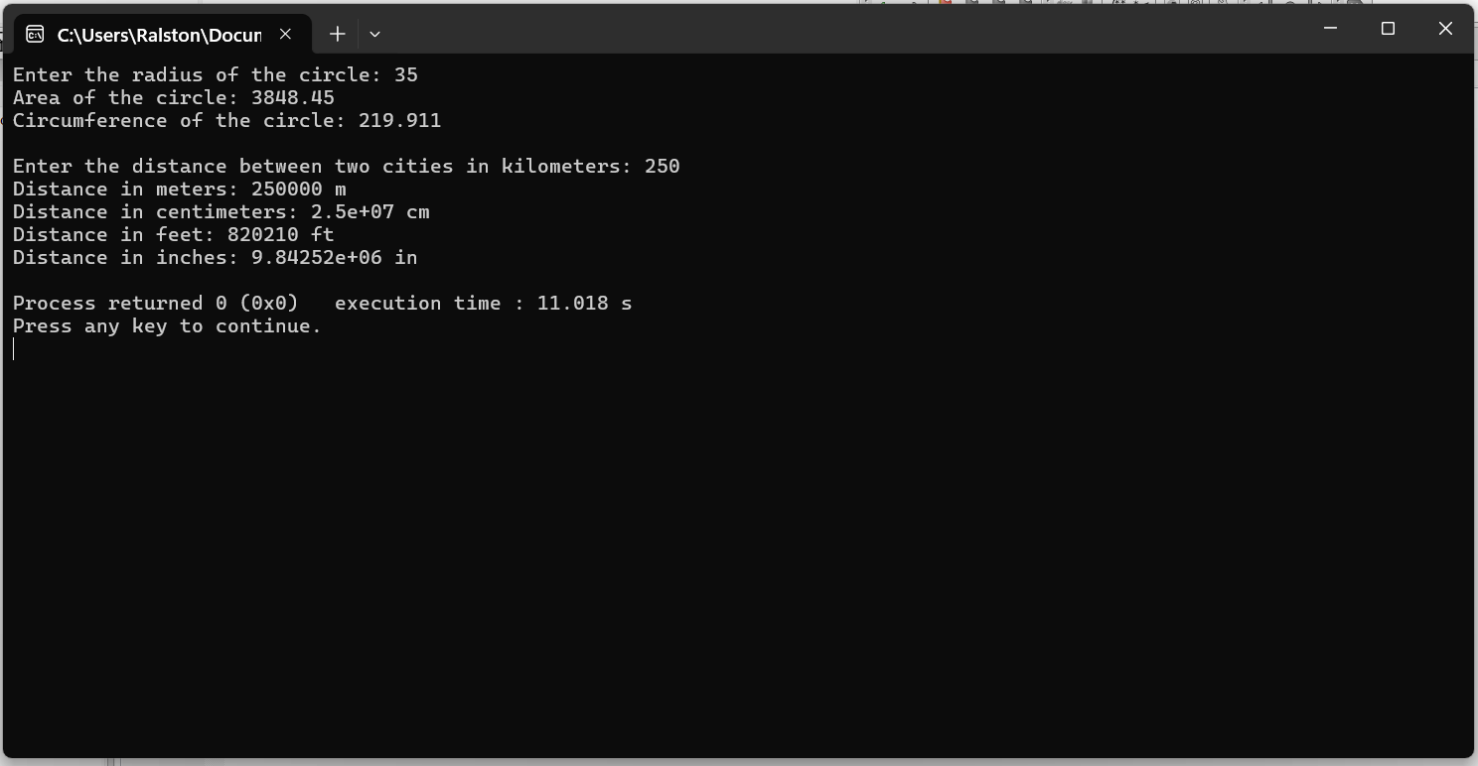

Post-Lab Subjective/Objective type Questions:
  - What are the basic data types in C++?
ANS: The basic data types in C++ include:
- int → Used to store whole numbers (like 5, -20, 1000).
- float → Used to store decimal numbers with less precision (like 3.14, 2.5).
- double → Used to store decimal numbers with more precision than float (like 3.14159265).
- char → Used to store a single character (like 'A', 'z', '1').
- bool → Used to store truth values: true (1) or false (0).
- void → Means "nothing". Usually used when a function does not return a value

  - Write a table for operator precedence and associativity.
ANS: Basic Operator Precedence in C++

Precedence (High → Low) Operators Associativity
--------------------------------------------------------------
1 (highest) () Left to Right
2 * / % Left to Right
3 + - Left to Right
4 < <= > >= Left to Right
5 == != Left to Right
6 && Left to Right
7 || Left to Right
8 = += -= *= /= Right to Left
9 (lowest) , Left to Right

Conclusion:
Detailed Conclusion:
In this experiment, we learned how to apply basic C++ programming concepts to solve real-world problems. By using input and output statements, arithmetic operations, and simple formulas, we successfully calculated the area and circumference of a circle. We also converted the distance between two cities from kilometers into meters, centimeters, feet, and inches. This exercise helped us understand the use of variables, data types, operators, and mathematical expressions in C++. Overall, the experiment strengthened our basics of programming and showed how C++ can be used effectively for practical applications.

Signature of faculty in charge with Date:

